**TrackWise Solutions**

**Mission statement:**

To analyze data on on-time performance, ridership, guest rewards, and employment to obtain insights on driving operational excellence across Amtrak’s network

**Mission objectives:**

1. To identify the top ten cities with the highest ridership to prioritize resource allocation.
2. To determine the top ten states with the largest year-over-year increase in guest reward enrollments to focus customer engagement efforts in regions with growing loyalty.
3. To identify the top ten states with the highest operational efficiency, (based on on-time performance and staffing ratios) creating benchmarks for other states.
4. To categorize routes according to their on-time performance to identify routes that can be used as benchmarks for improving the performance of other routes

**Business terms, facts, attributes and identifiers**

Station—The station is representative of every train station. A station code uniquely identifies a station, which is located in a city and state.

State - State represents each state in the US denoted by a state code consisting of 2 letters to uniquely identify a state.

On-Time Performance - On-Time Performance measures what proportion of customers arrive at their destination on time for the specific route. For Acela trains, the margin is within 10 minutes of the schedule and the margin is 15 minutes for all other trains. Thus, if a train is 16 minutes late to its final stop, and all its riders are headed for that stop, then even if the train is on time at every intermediate stop, customer OTP would be 0%, reflecting the passengers’ experience.

Ridership - Ridership refers to the count of passengers at each station, indicating the total number of people alighting or boarding trains at each station for each fiscal year from 2021 to 2023.

Guest Rewards - The *Amtrak Guest Rewards (AGR)* provides an overview of the program’s reach and demographic distribution. It includes key information such as the total number of AGR members at the end of the fiscal year and the number of members within each state.

Employment - Employment contains the number of people employed by Amtrak and the yearly employment expenditure at the end of the fiscal year at a state level.

Route - Route provides key details about each train route, it includes a unique route name assigned to each route. Route year states the year and routeOTP gives details about the on-time performance of the route in the respective year. Route type categorizes the route into Long Distance, State Supported, or Northeast Corridor.

**Entity Relationship Diagram**

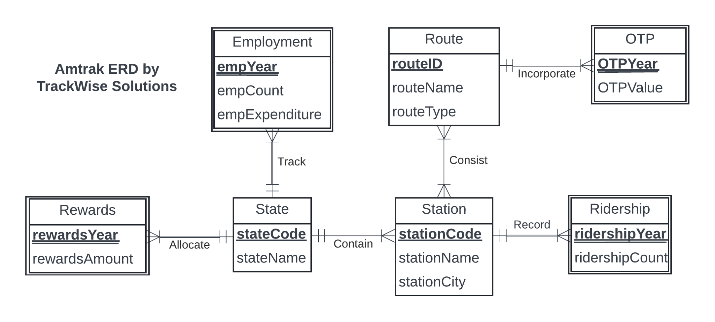

**Relations:**

State(**stateCode***,* stateName)

Rewards(***stateCode*,** **rewardsYear**, rewardsAmount)

Employment(***stateCode****,* **empYear**, empCount, empExpenditure)

Station(**stationCode**, stationName, stationCity, *stationStateCode)*

Consist(***routeID, stationCode)***

Route(**routeID*,*** routeName, routeType)

OTP(***routeID***, **OTPYear**, OTP)

Ridership(**s*tationCode***, **ridershipYear**, ridershipCount)

**Business Rules:**

**[R1]** Whenever a state is deleted from or changed in the database, all reward details should be deleted or changed accordingly.

**[R2]** Whenever a state is deleted from or changed in the database, all employment details should be deleted or changed accordingly.

**[R3]** For a state with stations in the database, the state cannot be deleted from the database.

**[R4]** For a state with stations in the database, if state details change, station details need to change accordingly.

**[R5]** When a route is deleted or changed in the database, the information for route-to-station mapping should be deleted or changed accordingly.

**[R6]** When a station is deleted or changed in the database, the information for station-to-route mapping should be deleted or changed accordingly.

**[R7]** When a Station is deleted or changed in the database, all Ridership details of the station should be deleted or changed accordingly.

**Referential Integrity Actions:**

|  |  |  |  |  |  |  |  |
| --- | --- | --- | --- | --- | --- | --- | --- |
| Relation | Foreign Key | Base Relation | Primary Key | Business Rule | ON DELETE | Business Rule | ON UPDATE |
| Rewards | rewardsStateCode | State | stateCode | R1 | CASCADE | R1 | CASCADE |
| Employment | empStateCode | State | stateCode | R2 | CASCADE | R2 | CASCADE |
| Station | stationStateCode | State | stateCode | R3 | NO ACTION | R4 | CASCADE |
| Consist | routeName | Route | routeName | R5 | CASCADE | R5 | CASCADE |
| Consist | stationCode | Station | stationCode | R6 | CASCADE | R6 | CASCADE |
| Ridership | ridershipStationCode | Station | stationCode | R7 | CASCADE | R7 | CASCADE |

**Example records for each relation:**

State(**stateCode***,* stateName)

State consists of the state code and the state name.

|  |  |
| --- | --- |
| **stateCode** | **stateName** |
| AL | Alabama |

Rewards(***rewardsStateCode*,** **rewardsYear**, rewardsAmount)

Rewards consist of the number of riders enrolled for guest rewards in the specific state.

|  |  |  |
| --- | --- | --- |
| **rewardsStateCode** | **rewardsYear** | **rewardsAmount** |
| AL | 2021 | 36069 |

Employment(***empStateCode****,* **empYear**, empCount, empExpenditure)

Each record in the Employment table consists of the state code, the fiscal year, count of employees, and the total expenditure amount.

|  |  |  |  |
| --- | --- | --- | --- |
| **empStateCode** | **empYear** | **empCount** | **empExpenditure** |
| AL | 2023 | 27 | ​​$1983661.00 |

Station(**stationCode**, stationName, stationCity, *stationStateCode)*

Station consists of the station code, station name, station city, and the state code of that station.

|  |  |  |  |
| --- | --- | --- | --- |
| **stationCode** | **stationName** | **stationCity** | **stationStateCode** |
| ATN | Anniston | Anniston | AL |

Consist(***routeID, stationCode)***

Each record in the consist table gives the mapping between route and station for the stations that the route connects.

|  |  |
| --- | --- |
| **routeID** | **stationCode** |
| R013 | ATN |

Route(**routeID*,*** routeName, routeType)

Each record in the Route table consists of the routeID, route name, and also categorizes the route to a route type.

|  |  |  |
| --- | --- | --- |
| **routeID** | **routeName** | **routeType** |
| R013 | Crescent | Long Distance |

OTP(***routeID***, **OTPYear**, OTP)

Each record in the OTP table consists of the routeID, which year the OTP value is for (OTPYear), and the respective OTP value.

|  |  |  |
| --- | --- | --- |
| **routeID** | **OTPYear** | **OTP** |
| R013 | 2021 | 54.6% |

Ridership(**ridership*StationCode***, **ridershipYear**, ridershipCount)

Each record in ridership consists of the count of rides for the corresponding year and station code.

|  |  |  |
| --- | --- | --- |
| **ridershipStationCode** | **ridershipYear** | **ridershipCount** |
| ATN | 2021 | 1948 |

**Cardinalities:**

1. Each state can have one or more stations but each station belongs only to one state.
2. Each state can have one or more reward records but each reward is associated with only one state.
3. Each state can have one or more employment but each employment must belong to only one state.
4. Each station can have one or more riderships but one ridership must be associated with only one station,
5. Each route can contain one or more stations and each station can be used by one or more routes.